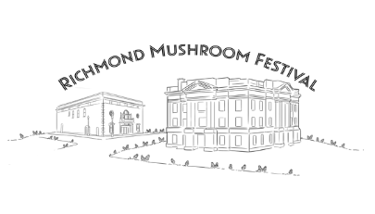
2022 Entertainment Registration Form
MUSHROOM FESTIVAL 41 – MAY 6TH – 7TH

Entertainment: __________________________________________________________________________

Name of Entertainer: ___________________________________________________________________________

Phone: Daytime________________________________ Cell: _____________________________________________

Street Address: ______________________City: ____________________ State: _____________Zip: _______________

Email: (Required) __________________________________________________________________________________

Fees: _____________________________________ Performance Length: _____________________________

Electricity needed for Performance: ________________________________________________________________

Description of entertainment: ____________________________________________________________________

________________________________________________________________________________________________

To complete your Registration Form. Please sign the 2022 Mushroom Festival Indemnity Agreement.

I AGREE TO INDEMNIFY AND HOLD HARLESS THE CITY OF RICHMOND, THE FRIENDS OF THE FARRIS, INC, AND MUSHROOM FESTIVAL COMMITTEE, AND ITS DIRECTORS AND AGENTS FROM AND AGAINST ALL CLAIMS, DAMAGES, LOSSES AND EXPENSES ARISING OUT OF THE ACTIVITIES RELATING TO 2022 MUSHROOM FESTIVAL. I HAVE READ AND AGREE TO THE TERMS OUTLINED ON THE VENDOR REGISTRATION FORM AND FURTHER ACKNOWLEDGE THAT ENTRY FEES AND ELECTRICAL CHARGES ARE NON-REFUNDABLE.
I AGREE THAT I AM SOLELY RESPOSIBLE FOR MY PROPERTY DURING FESTIVAL. THE FRIENDS OF THE FARRIS, INC. & MUSHROOM FESTIVAL COMMITTEE RESERVE THE RIGHT TO REFUSE AND OR CANCEL ANY REGISTRATION IN VIOLATION WITH AGREEMENT.

SIGNED: ___________________________________________ DATE: _________________________________

Please return the completed registration form to: Friends of the Farris, Inc., 301 W. Main St., Richmond, MO 64085
DEADLINE IS FRIDAY, APRIL 8, 2022

If you have any questions, please contact Lesley Green (816)776-6684, email at exedirector@farristheatre.com

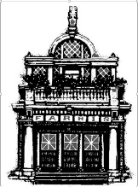
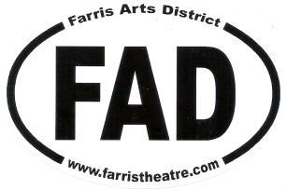
Follow us on Facebook!
Richmond Missouri Annual Mushroom Festival
www.mushroomfestival.net

